PROJECT WORK

AI-Based Body Language And Emotion Detection System Using Computer Vision
Bonafide Work Done by VASANTH.VM 2328F0026
Under the Guidance of

Mrs. K. Yasotha, MCA., M.Phil., NET, (Ph.D.),
Assistant Professor

Dissertation submitted in partial fulfillment of the requirements for the award of

Bachelor of Science in Computer Science (Artificial Intelligence)
of Bharathiar University, Coimbatore – 641 046.



DEPARTMENT OF COMPUTER SCIENCE

PPG COLLEGE OF ARTS AND SCIENCE
(Affiliated to Bharathiar University, Coimbatore – 641 046)
SARAVANAMPATTI, COIMBATORE – 641 035

MARCH – 2026


(Affiliated to Bharathiar University, Coimbatore – 641 046)

SARAVANAMPATTI, COIMBATORE – 641 035

BONAFIDE CERTIFICATE

This is to certify that the project work entitled “AI-BASED BODY LANGUAGE AND EMOTION DETECTION SYSTEM USING COMPUTER VISION” is
abonafide record of work done by VASANTH.VM (2328F0026) in partial fulfillment of the requirements for the award of the degree of Bachelor of Science in Computer Science (Artificial Intellgence) to be awarded by Bharathiar University, Coimbatore. This project work has been carried out by the student under the supervision and guidance of
Mrs. K. Yasotha, MCA., M.Phil., NET, (Ph.D.), Assistant Professor, Department of Computer Science during the academic year 2025 – 2026.

Signature of the Guide Signature of the HOD

Submitted for the Viva-Voce Examination held on

Internal Examiner External Examiner

DECALARATION

I hereby declare that the project entitled “AI-BASED BODY LANGUAGE AND EMOTION DETECTION SYSTEM USING COMPUTER VISION” submitted
by VASANTH.VM ( 2328F0026 ) in partial fulfilment of the requirements for the award of the degree of Bachelor of Science in Computer Science (Artificial Intelligence) at PPG College of Arts and Science, is a record of bonafide project work carried out by me under the guidance of Mrs. K. Yasotha, MCA., M.Phil., NET, (Ph.D.), Assistant Professor, Department of Computer Science. I further declare that this project report has not been submitted, either in part or in full, for the award of any other degree or diploma in this institution or any other institution or university.

Date: Signature by the Candidate

Place: Coimbatore VASANTH.VM

ACKNOWLEDGEMENT

I wish to convey my heartfelt thanks to our Honourable Chairman, Dr. L. P. Thangavelu, M.S., FAIS, FIAGES, FICS, Founder-Chairman, PPG Group of Institutions, who has always encouraged me to give my best.

I express my sincere thanks and gratitude to our beloved Correspondent, Mrs. Shanthi Thangavelu, and our Vice-Chairman, Mr. Akshay Thangavel, for providing all the necessary facilities and support for the successful completion of this project.
For the successful completion of this project, many individuals have contributed, and their support is truly invaluable. I wish to express my deep gratitude to our beloved Principal, Dr.
N. Muthumani, M.Sc., M.Phil., NET, Ph.D., and thank her profusely for her motivation and moral support throughout this work.
I heartily thank Mrs. K. Yasotha, MCA., M.Phil., NET, (Ph.D.), Head of the Department, who has been a source of constant encouragement, moral strength, and guidance throughout this project.
I take this opportunity to express my sincere gratitude to my project guide, Mrs. K. Yasotha, MCA., M.Phil., NET, (Ph.D.), Assistant Professor, Department of Computer Science, for his invaluable guidance, continuous support, and tremendous encouragement, which greatly contributed to the successful completion of this project.

I also express my sincere thanks to the teaching and non-teaching faculty members of the Department of Computer Science, PPG College of Arts and Science, for their valuable support and cooperation throughout the project work.

Finally, I am grateful to my parents and friends for their encouragement, constant support, and keen interest during the course of this project work.

TABLEOFCONTENT

CHAPTER  NO. | TITLE | PAGE NO.
 | SYNOPSIS | 1-4
1 | INTRODUCTION | 2
 | 1.1 ORGANIZATION PROFILE | 2
 | 1.2 SYSTEMSPECIFICATION | 4
 | 1.2.1 HARDWARE SPECIFICATION | 4
 | 1.2.2 SOFTWARE SPECIFICATION | 4
2 | SYSTEM STUDY | 5-8
 | 2.1 EXISTINGSYSTEM | 5
 | 2.1.1 DRAW BACK OF EXISTING SYSTEM | 6
 | 2.2 PROPOSED SYSTEM | 6
 | 2.2.1 FEATURE OFPROPOSED SYSTEM | 8
3 | SYSTEMDESIGN AND DEVELOPMENT | 9-13
 | 3.1 INPUT DESIGN | 9
 | 3.2 OUTPUT DESIGN | 10
 | 3.3 SYSTEM DEVELOPMENT | 11
 | 3.3.1 DESCRIPTION OF MODULES | 12
 | 3.4 ALGORITHM | 13
4 | TESTING AND IMPLEMENTATION | 14-
 | 4.1 TESTING | 14
 | 4.2 IMPLEMENTATION | 16
5 | CONCLUSION | 17
6 | BIBLIOGRAPHY | 18
 | 6.1 BOOK REFERENCE | 18
 | 6.2 WEBSITE REFERENCE | 18
7 | APPENDICES | 19-27
 | A. DATAFLOW DIAGRAM | 20
 | B. SCREENSHOTS | 21
 | C. CODING | 24

SYNOPSIS

The rapid growth of Artificial Intelligence and Computer Vision technologies has created new opportunities for machines to understand human behavior through visual data. Human communication is not limited to spoken words it also involves non-verbal signals such as facial expressions, gestures, and body posture. These signals often reveal emotions and intentions more accurately than verbal communication. However, in real-world environments such as job interviews, meetings, training sessions, and presentations, it can be difficult for humans to continuously observe and analyze these subtle cues.
The “AI-Based Body Language and Emotion Detection System” is designed to analyze facial expressions and body language using computer vision and machine learning techniques. The system captures real-time video input through a webcam and processes the visual frames using advanced image processing algorithms. Facial detection models identify key facial features, while pose detection frameworks analyze body posture and gestures. These features are then evaluated by machine learning models to classify emotions such as happiness, sadness, anger, surprise and neutrality.
The system is implemented using Python and several powerful libraries such as OpenCV, MediaPipe, TensorFlow, and DeepFace. These technologies enable accurate detection and analysis of facial expressions and body posture from live video streams. The processed results are displayed through an interactive dashboard interface that presents emotion analysis and behavioral insights.
This project demonstrates how artificial intelligence can be used to interpret human emotions automatically. The proposed system can be applied in various fields such as interview analysis, online meeting engagement monitoring, behavioral research, and intelligent training systems.

1

INTRODUCTION

ORGANIZATION PROFILE


Gateway Software Solutions is a professional software development and IT training organization that focuses on providing innovative technology solutions and practical learning opportunities for students and professionals. The organization aims to bridge the gap between academic knowledge and real-world industry requirements by offering hands-on training and project development in various modern technologies.
Gateway Software Solutions was established with the objective of helping businesses and individuals adopt advanced software technologies to improve efficiency and productivity. The company specializes in developing customized software applications, web-based systems, and database-driven solutions for various industries. By utilizing modern programming languages, frameworks, and development tools, the organization ensures that the software solutions it develops are reliable, scalable, and user-friendly.
The organization provides services in several areas such as web development, application development, database management, cloud solutions, and artificial intelligence-based systems. It focuses on building secure and efficient systems that meet the needs of businesses and organizations. Gateway Software Solutions follows a structured software development process that includes requirement analysis, system design, coding, testing, and implementation to deliver high-quality software products.
Gateway Software Solutions is a dynamic software development and IT training organization dedicated to delivering innovative technology solutions and industry-oriented learning experiences. The company focuses on bridging the gap between academic knowledge and real-world industry requirements by providing practical, hands-on training and live project development for students and professionals. It specializes in developing customized software applications, web-based platforms, and database-driven systems tailored to meet the needs.

2



Date: 28.02.2026 PROJECT COMPLETION LETTER
This is to certify that VASANTH.VM (2328F0026), student studying III year B.SC COMPUTER SCIENCE (Artificial Intelligence) at PPG COLLEGE OF ARTS AND SCIENCE, has been successfully completed the final year project on the topic of “AI-Based Body Language and Emotion Detection System” in our concern for the period of December 2025 to February 2026.

Good Conduct and Time Management is appreciated.

SYSTEM SPECIFICATION

The system specification describes the hardware and software requirements needed for the proper functioning of the proposed system. Since the project involves real-time video processing and machine learning analysis, the system must have sufficient computational capability to process image data efficiently. The system uses a webcam to capture real-time video frames of the user. These frames are processed using computer vision algorithms to detect facial landmarks and body posture. The extracted features are then analyzed using machine learning models to determine the emotional state of the user. Python is used as the primary programming language because it provides powerful libraries for artificial intelligence and image processing. OpenCV is used for capturing and processing video frames, while MediaPipe detects facial landmarks and body pose. Deep learning models analyze facial expressions and classify emotions. The final results are displayed through an interactive dashboard built using Streamlit, which presents emotion detection results in graphical form for easy understanding.

1 HARDWARE SPECIFICATION

- Processor: Intel i5 or above
- RAM: 8 GB (Minimum)
- Storage: 512 GB HDD / SSD
- Network: Stable Internet Connection
- Client Devices: Desktop
- Camera: Integrated or External Webcam

1.2.2 SOFTWARE SPECIFICATION

- Operating System: Windows 10 / Windows 11
- Programming Language : Python
- Libraries: OpenCV, MediaPipe, DeepFace, TensorFlow
- Framework: Streamlit
- Development Tools: VS Code

CHAPTER II SYSTEM STUDY

EXISTING SYSTEM

The System study is an important phase in system development where the existing methods are analyzed and the requirements for a new system are identified. In the context of body language and emotion detection, traditional methods rely mainly on human observation. Observers attempt to analyze facial expressions and body posture to determine emotional states. However, manual observation may not always be accurate because emotions can change rapidly and subtle signals may be overlooked.
The system study highlights the need for an automated solution that can continuously monitor visual data and provide real-time behavioral insights. Computer vision and machine learning technologies provide the ability to analyze visual information quickly and accurately. By studying existing methods and their limitations, the proposed system is designed to provide a more efficient and reliable approach for detecting emotions and analyzing body language.

Existing emotion detection systems are often based on manual observation or simple image processing techniques. In many environments such as interviews and meetings, evaluators analyze body language by observing facial expressions and gestures.While experienced observers may identify certain emotional patterns, this method is subjective and depends on individual interpretation. Different observers may interpret the same behavior differently, leading to inconsistent results.

Some existing digital tools focus only on facial recognition and do not consider body posture or gestures. As a result, the emotional analysis may not be completely accurate because body language plays an important role in communication.Therefore, there is a need for a more advanced system that can analyze multiple behavioral signals simultaneously and provide accurate emotion detection results

DRAW BACK OF EXISTING SYSTEM

The major drawbacks of the existing system:

      - Manual observation may lead to subjective interpretation.

      - Subtle emotional cues may be missed.

      - Existing systems may analyze only facial expressions.

      - Lack of real-time emotion analysis.

      - Limited visualization of analysis results.

PROPOSED SYSTEM

The proposed system introduces an intelligent solution that uses artificial intelligence to analyze human emotions and body language automatically. The system captures video input from a webcam and processes the frames using computer vision algorithms. Facial detection models identify facial landmarks, while pose detection frameworks analyze body posture and gestures. Machine learning models interpret these signals and classify emotions such as happiness, sadness, anger, surprise, and neutrality.

The system also includes a dashboard interface that displays emotion detection results through graphs and tables. This visualization helps users understand emotional patterns and behavioral responses easily. The proposed system provides a comprehensive platform for analyzing human behavior using artificial intelligence technologies.

The system follows a controlled and secure workflow:
Start
End
Human & Pose
Detect

START
Camera Input (Webcam/Video)

Human & pose
Detect
Emotion detection ML model
Frame Processing (Capture & Clean)
Result Display
END

FEATURE OF PROPOSED SYSTEM

The salient features of the proposed system are outlined below:

      - The system uses AI and Machine Learning to detect human emotions.
      - It captures real-time video using a webcam.
      - The system detects face and body movements from video frames.
      - It processes images using computer vision techniques.
      - Facial expressions are analyzed to identify emotions.
      - Body posture is used to support emotion detection.
      - The system can detect emotions like happy, sad, angry, and neutral.
      - Results are shown in real-time on a dashboard.
      - The system is developed using Python and AI libraries.
      - It can be used for interviews, meetings, and behavior analysis.

CHAPTER III
SYSTEM DESIGN AND DEVELOPMENT

INPUT DESIGN

The Input design is an important part of the system that defines how data is entered for processing. In the proposed system, the main input is real-time video captured using a webcam. The camera records live video frames of the user while the system is running. These frames are used to analyze facial expressions and body posture.The captured video frames are first converted into images for processing. Image preprocessing techniques such as resizing and noise removal are applied to improve the quality of the input data. This helps the system process the images more efficiently.After preprocessing, computer vision algorithms detect the human face in the frame. The system also detects body posture and key points such as head and shoulder positions. These features provide useful information for analyzing body language.The extracted features are then given to the machine learning model as input. The model analyzes these features to identify the emotional state of the user. The system processes the input data continuously to provide real-time emotion detection results.

Categories of Input Design
    - Manual Input
    - Automatic Input
    - Online Input
    - Batch Input
    - Real-Time Input Manual Input
Manual input refers to the data entered directly by the user into the system. It is usually done using input devices such as a keyboard, mouse, or touch screen. This method requires human interaction to provide the necessary information.

Automatic Input

Automatic input is the process where data is captured automatically by the system without manual effort. Devices such as sensors, cameras, and scanners collect the required data. This method improves efficiency and reduces human errors.

Online Input

Online input is data entered directly into the system while it is running. The data is processed immediately after it is entered. This method is used in systems that require instant processing.

Batch Input

Batch input is data collected over a period of time and processed together later. The data is stored first and then handled as a group. This method is useful for processing large amounts of data.

Real-Time Input

Real-time input is data that is captured and processed instantly by the system. The system analyzes the input as soon as it is received. It is used in applications that require quick responses.

OUTPUT DESIGN

Output design focuses on how the results of the system are presented to the user. The main aim of output design is to display information in a clear and understandable format. In this system, the output shows the detected emotions based on facial expressions and body language analysis.The system processes the captured video frames and identifies emotions such as happy, sad, angry, or neutral. These results are displayed on the screen in real time. The output is shown through an interactive dashboard.The dashboard is developed using Streamlit, which provides a simple and user-friendly interface.

Types of System Outputs

    - Text Output – Information displayed in the form of text messages or written results on the screen.
    - Graphical Output – Data shown using graphs, charts, or visual representations for better understanding.
    - Audio Output – Output provided in the form of sound or voice through speakers.
    - Video Output – Information displayed through video or visual frames on the screen.
    - Printed Output – Results that can be printed on paper using a printer.

SYSTEM DEVELOPMENT

System development is the process of designing, building, and implementing a software system to solve a specific problem. In this project, the system is developed to detect human emotions and body language using Artificial Intelligence and Computer Vision techniques. The development process includes stages such as planning, system design, coding, testing, and implementation.
The system is developed using the Python programming language because it provides powerful libraries for machine learning and image processing. Libraries such as OpenCV, MediaPipe, and DeepFace are used to perform face detection, pose detection, and emotion analysis.
The development process begins with capturing real-time video input from a webcam. The webcam continuously records video frames while the system is running. These frames are then converted into images and processed by the system.
Image preprocessing techniques such as resizing and noise removal are applied to improve the quality of the captured frames. After preprocessing, computer vision algorithms detect the human face and body posture in the image. Facial landmarks and body keypoints are extracted for further analysis.
These extracted features are given as input to the machine learning model. The model analyzes the features and identifies the emotional state of the user. The system can classify emotions such as happy, sad, angry, and neutral.

The results are displayed through an interactive dashboard developed using Streamlit. The dashboard shows the detected emotions in real time and allows users to easily understand the analysis results.
Overall, the developed system combines computer vision and machine learning techniques to perform real-time emotion detection and body language analysis.

DESCRIPTION OF MODULES

Description of modules refers to explaining the different parts of the system and how each part performs a specific function. In a software system, the entire application is divided into smaller modules so that each module handles a particular task. This modular approach makes the system easier to design, develop, and maintain. Each module works together with other modules to complete the overall process of the system. In the proposed AI-based body language and emotion detection system, different modules are used to capture video input, process images, detect facial expressions and body posture, and identify emotions. These modules work sequentially to analyze the user's behavior and generate accurate results. By dividing the system into modules, the system becomes more organized, efficient, and easier to manage.

Video Input Module

This module is responsible for capturing real-time video from the webcam. The webcam records the user's face and body movements continuously while the system is running. The captured video frames act as the primary input for the emotion detection system.

Image Preprocessing Module

In this module, the captured video frames are processed to improve image quality. Techniques such as resizing, noise removal, and normalization are applied. These preprocessing steps help improve the accuracy and efficiency of the detection process.

Face Detection Module

This module detects the human face in the captured frames using computer vision algorithms. It identifies the position of the face in the image and extracts important facial regions. This step is important for analyzing facial expressions.

Body Pose Detection Module
The body pose detection module identifies key points of the human body such as the head, shoulders, and arms. This helps analyze body posture and gestures. Body language information supports the emotion detection process.

Emotion Detection Module
This module uses machine learning models to analyze facial expressions and body posture. The extracted features are processed to determine the emotional state of the user. The system can detect emotions such as happy, sad, angry, and neutral.

ALGORITHM

• Input Acquisition
Capture real-time video or image input using a webcam.

• Preprocessing
Convert input into suitable format (resize, normalize, RGB conversion).

• Face Detection
Identify and extract the face region from the input frame.

• Emotion Recognition
Analyze facial expressions using a trained AI model to detect emotions.

• Pose Detection
Detect body posture and key landmarks using computer vision techniques.

• Body Language Analysis
Interpret gestures and posture to understand user behavior.

• Result Integration
Combine facial emotion and body language outputs.

• Output Generation
Display detected emotion and behavior on the screen.

CHAPTER IV
TESTING AND IMPLEMENTATION

TESTING

Testing is an important phase in the development of a software system. It is used to check whether the system works correctly and produces accurate results. The main purpose of testing is to identify errors and ensure that the system performs as expected. In this project, testing is performed to verify the functionality of the emotion detection system. The system is tested by capturing real-time video through a webcam and analyzing facial expressions and body language. Different users are tested to observe how accurately the system detects emotions. Various lighting conditions and environments are also used to evaluate the system's performance.

The input frames are processed and the detected emotions are displayed on the dashboard. During testing, the system is checked for errors, performance issues, and accuracy of the results. If any problems occur, they are corrected during the testing phase. This process helps improve the reliability and efficiency of the system. Overall, testing ensures that the proposed system functions properly and provides correct emotion detection results.

Objectives of System Testing

The testing phase is designed to achieve the following objectives:

    - To verify that the system works according to the specified requirements.
    - To identify errors or bugs present in the system.
    - To ensure that all modules of the system function correctly.
    - To check the accuracy and reliability of the system output.
    - To evaluate the overall performance of the system.
    - To ensure that the system works properly under different conditions.

Types of Testing Performed

- Unit Testing

Unit testing is performed to test individual modules of the system separately. Each module is checked to ensure that it works correctly. This helps identify errors in the early stage of development.

Integration Testing

Integration testing is used to check how different modules of the system work together. It ensures that the modules interact properly without errors. This testing verifies the communication between system components.

System Testing

System testing is performed to evaluate the complete system as a whole. It checks whether all the modules function together according to the system requirements. This testing ensures that the system performs the expected tasks.

Performance Testing

Performance testing is used to measure the speed and efficiency of the system. It checks how well the system processes video frames and detects emotions in real time. This testing ensures that the system works smoothly without delays.

User Acceptance Testing

User acceptance testing is conducted to verify whether the system meets user requirements. Real users test the system to confirm that it works correctly and provides accurate results. This testing ensures that the system is ready for practical use.

IMPLEMENTATION

System Setup

The first step in implementation is setting up the development environment. Required software such as Python and necessary libraries are installed to support the system development.

Video Input Integration

The webcam is integrated with the system to capture real-time video. The system continuously records video frames which act as input for the emotion detection process.

Image Processing Implementation

Captured video frames are processed using image preprocessing techniques. Methods such as resizing and noise removal are applied to improve the quality of the input images.

Face and Pose Detection

Computer vision algorithms are implemented to detect human faces and body posture. Tools like OpenCV and MediaPipe are used to identify facial landmarks and body keypoints.

Dashboard Development

A user interface is developed using Streamlit to display the results. The dashboard shows real- time emotion detection results and provides a clear visualization of the analysis.

CHAPTER V CONCLUSION
The AI-Based Body Language and Emotion Detection System is designed to analyze human emotions using computer vision and machine learning techniques. The system captures real-time video input through a webcam and processes the frames to detect facial expressions and body posture. By analyzing these visual features, the system is able to identify emotional states such as happy, sad, angry, and neutral. This helps in understanding human behavior and emotional responses more effectively. The proposed system integrates different technologies such as Python, OpenCV, MediaPipe, and machine learning models to perform accurate emotion detection. Image preprocessing techniques improve the quality of the captured frames, which helps the system analyze facial features and body language more efficiently. The extracted features are then used by the machine learning model to classify emotions.
The output is through an interactive dashboard that shows the detected emotions in real time. This makes it easier for users to understand the emotional analysis clearly. The system is designed to be simple, efficient, and user-friendly, requiring only a webcam for operation. This project demonstrates how artificial intelligence can be used to analyze nonverbal communication such as facial expressions and body posture. It can be useful in areas like job interviews, online meetings, behavioral analysis, and human-computer interaction. Overall, the developed system provides an effective solution for real-time emotion detection and body language analysis.

CHAPTER VI BIBLIOGRAPHY

BOOK REFERENCE

The Emotion Machine
      - Emotion & AI relation explain pannum (core concept)

Computer Vision: Algorithms and Applications
      - Computer vision basics (image processing + detection)

Deep Learning
      - CNN, neural networks (emotion detection-ku use)

Pattern Recognition and Machine Learning
      - ML algorithms (classification, prediction)

Hands-On Machine Learning with Scikit-Learn, Keras & TensorFlow
      - Practical implementation (your project coding-ku useful)

Artificial Intelligence: A Modern Approach
      - Full AI concepts (theory + application)

Learning OpenCV 4 Computer Vision with Python
      - OpenCV use panni face/body detection

Affective Computing
      - Emotion recognition (VERY IMPORTANT for your topic)

Machine Learning Yearning
      - Model building & improvement

Human-Computer Interaction
a. Human behaviour & interaction (body language concept)

WEBSITE REFERENCE

    - https://www.tensorflow.org

    - https://opencv.org

    - https://mediapipe.dev

4 .https://www.mdpi.com/2076-3417/9/21/4678

5. .https://www.matjournals.net/engineering/index.php/JoIDTA/article/view/641

CHAPTER VII APPENDIX

DATA FLOW DIAGRAM

DFD Level 0

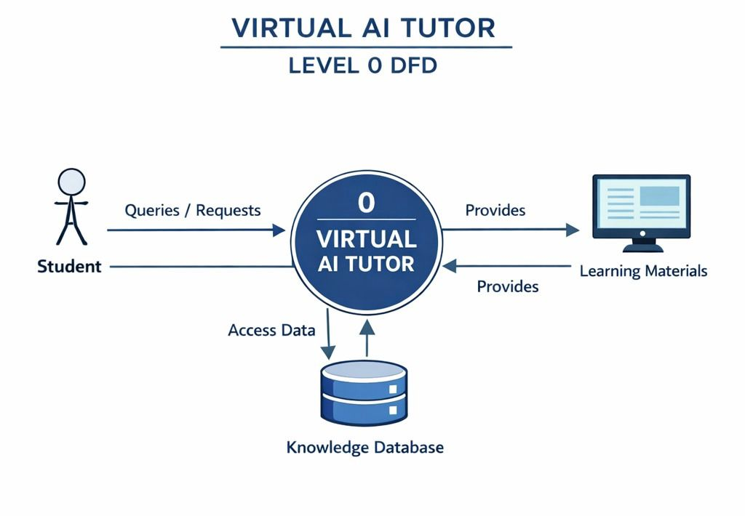

Components Explanation

- Student: Sends queries and receives answers.
- Virtual AI Tutor (System): Processes queries and generates responses.
- Knowledge Database: Stores all learning data used by the system.
- Learning Materials: Provides study content to the student.

Flow: Student → AI Tutor → Database → AI Tutor → Student

DFD Level 1: Key Management System
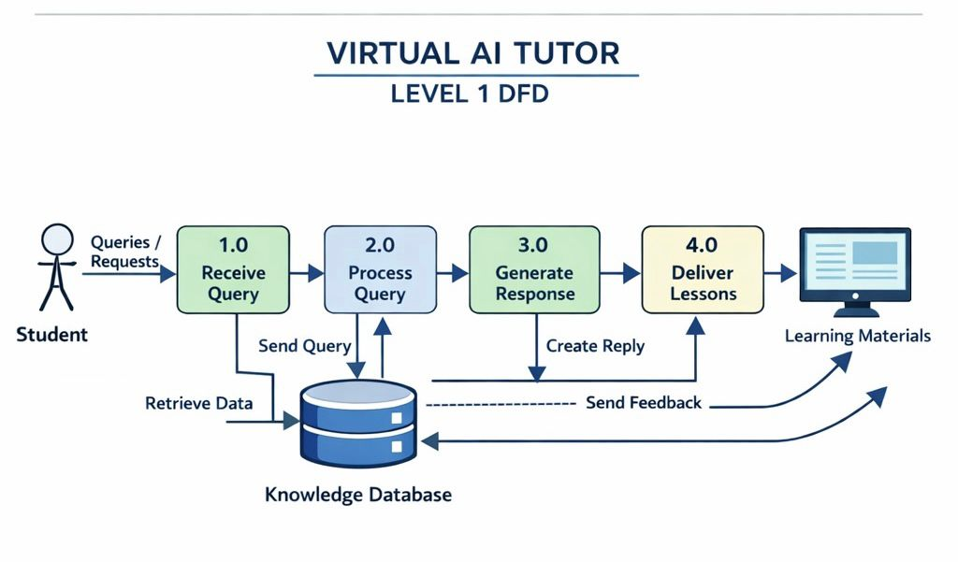

COMPONENTS EXPLANATION:

- Receive Query: Takes input from student.
- Process Query: Understands and analyzes question.
- Generate Response: Creates AI answer using database.
- Deliver Lessons: Sends final learning content to student.
- Knowledge Database: Stores and provides information.

Flow: Receive → Process → Generate → Deliver → Student

- SCREENSHOTS

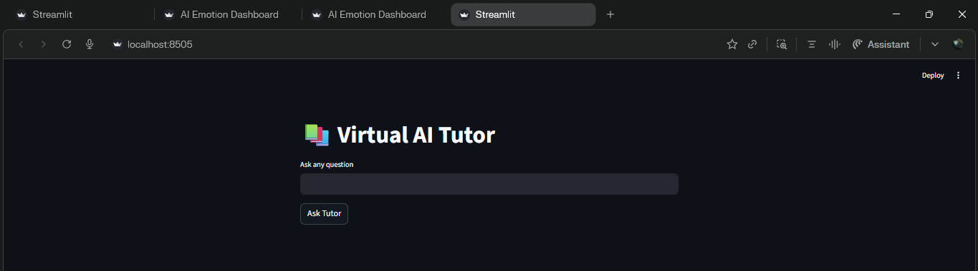


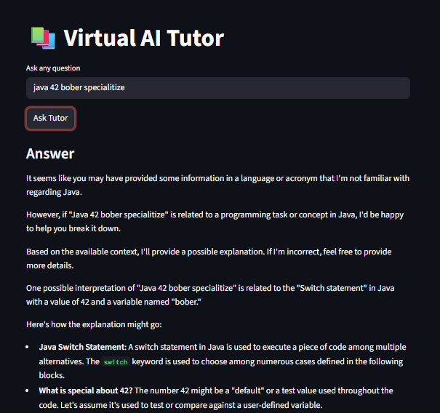

C.CODING

# =========================================================
# PROJECT TITLE: VIRTUAL AI TUTOR
# DESCRIPTION: AI-based student tutor system using Streamlit and Groq API
# =========================================================

# =========================
# IMPORT LIBRARIES
# =========================
import streamlit as st
from groq import Groq

# Description:
# Streamlit → UI creation
# Groq → AI model API access

# =========================
# API CONFIGURATION
# =========================
client = Groq(api_key="YOUR_API_KEY_HERE")

# Description:
# Connects application with Groq AI service

# =========================
# APPLICATION TITLE
# =========================
st.title("📚 Virtual AI Tutor")

# Description:
# Displays main heading of the web app

# =========================
# 📌 USER INPUT SECTION
# =========================
question = st.text_input("Ask any question")

# Description:
# Takes question from student/user

# =========================
# 📌 BUTTON CLICK EVENT
# =========================
if st.button("Ask Tutor"):

# =========================
# 📌 PROMPT CREATION
# =========================
prompt = f"""
You are a helpful AI tutor.
Explain the concept clearly in simple language for students.

Question: {question}
"""

# Description:
# Converts user question into AI instruction format

# =========================
# 📌 AI MODEL RESPONSE
# =========================
response = client.chat.completions.create(
model="llama-3.1-8b-instant",
messages=[
{"role": "user", "content": prompt}
]
)

# Description:
# Sends request to AI model and gets response

# =========================
# 📌 EXTRACT ANSWER
# =========================
answer = response.choices[0].message.content

# Description:
# Extracts final answer from AI response

# =========================
# 📌 DISPLAY OUTPUT
# =========================
st.write("### Answer")
st.write(answer)

# Description:
# Shows AI-generated answer on screen

